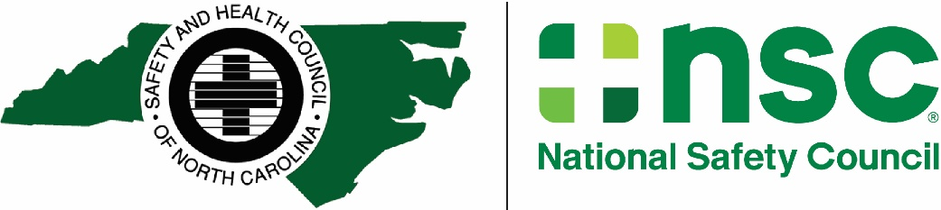

July 19, 2022

MEMO TO: DDC Community College Training Agencies “Option 1”

RE: DDC Student Completion Price Adjustment

We realize that there is never a good time for price increases, but SHCNC has recently been notified of a substantial price increase that becomes effective September 1, 2022, by the National Safety Council. We wanted to make you aware that the price increase affects all NSC Defensive Driving Course student materials, instructor materials, certification fees, and E-Learning instructor training. These costs will be described in the Winter 2022 DDC catalog which we will make available as soon as possible. In addition, the administrative fee we charge for students completing DDC at your college will also be adjusted.

Effective September 1, 2022, we must adjust pricing as outlined below:
Current price per student: Effective September 1, 2022:
4-Hour Class $6 $7
8-Hour Class $12 $14
12-Hour Class $25 $30

The Safety and Health Council greatly values our partnership to keep roads safer for all of us. We welcome the opportunity to meet with you and your district attorney to increase DDC attendance at your college. More people (1,755) have been killed on North Carolina roads in 2021 than any year since 1972. Our Defensive Driving Courses have never been more relevant-and needed-than today!

Sincerely,
Charles F. “Chip” McDonald, Jr., CAE
President

